
Foundations of Programming
Assignment No. : 10
PROBLEM STATEMENT:
Write a program in C to simulate a simple calculator that performs basic arithmetic operations such as addition, subtraction, multiplication, and division. The calculator should also perform special operations like computing xʸ (power) and x! (factorial).
OBJECTIVE:
• To understand the use of switch-case statements in C.
• To perform basic arithmetic and special mathematical operations.
• To enhance problem-solving skills using menu-driven programs.
THEORY:
A calculator is a basic computing device used to perform arithmetic operations. In C programming, a simple calculator can be implemented using conditional or switch-case statements. Arithmetic operations like addition, subtraction, multiplication, and division are fundamental operations. Special operations such as power (xʸ) and factorial (x!) require loops for repeated calculations.
PLATFORM:
Linux
ALGORITHM:
1.Start
2.Display menu:
1) Addition
2) Subtraction
3) Multiplication
4) Division
5) Power (xʸ)
6) Factorial (x!)
3.Input user choice
4.Use switch-case:
Case 1: Input two numbers → add
Case 2: Input two numbers → subtract
Case 3: Input two numbers → multiply
Case 4: Input two numbers → divide (check denominator ≠ 0)
Case 5: Input x, y → calculate power using loop
Case 6: Input number → calculate factorial using loop
5.Display result
6.Stop

FLOWCHART :
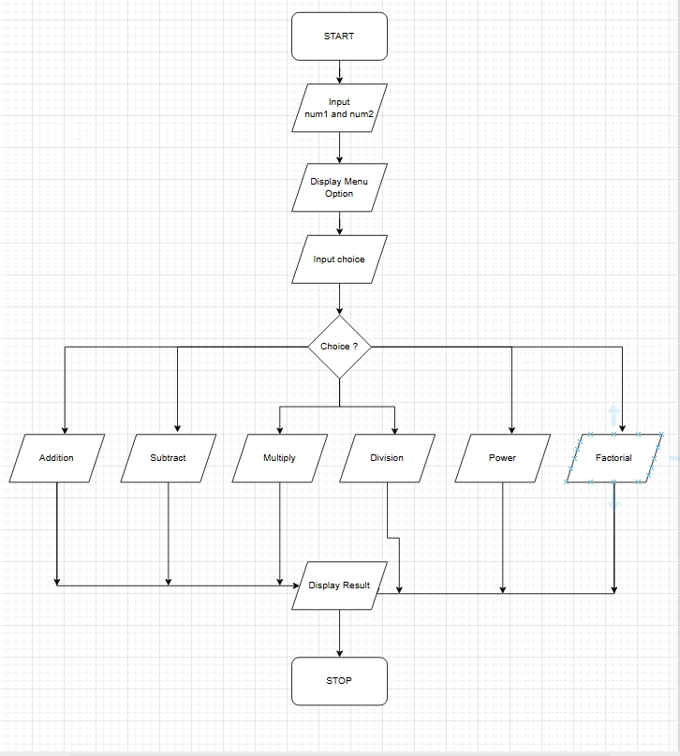
C PROGRAM :
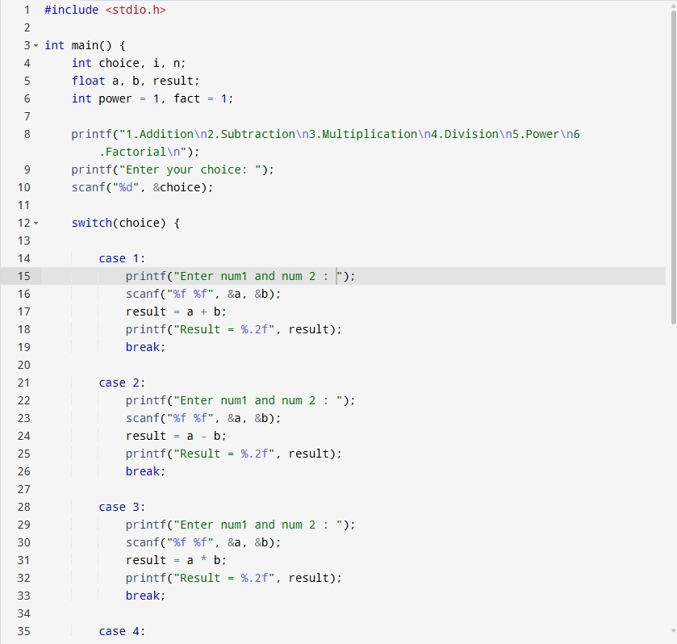
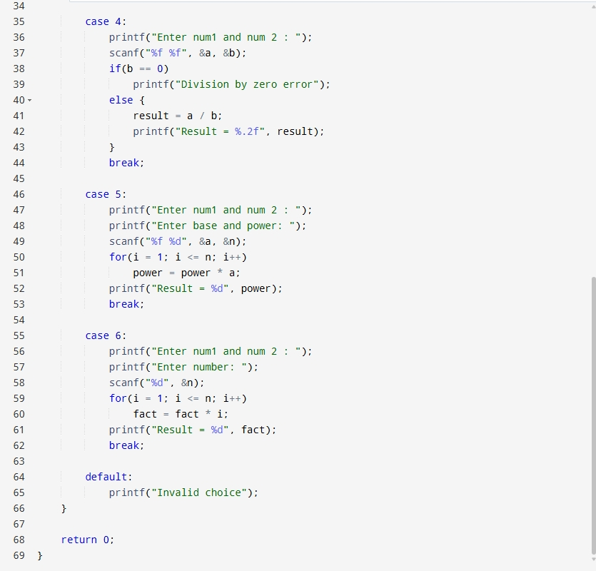
INPUT:
User selects an operation from the menu and enters required values.
Example Input:
Choice: 1
Numbers: 10 20
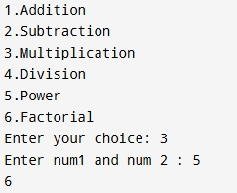
OUTPUT:
Example Output:
Result = 30.00
CONCLUSION:
Thus, a simple calculator program was successfully implemented using C programming. The program demonstrates the use of switch-case statements, loops, and arithmetic operations.
FAQs:
- What is a simple calculator program?
- Why is switch–case preferred in calculator programs?
- How does the program handle division by zero?
- How is the power operation (xʸ) implemented without using math library functions?
- What is factorial and how is it calculated using loops in C?

